Eckert 8: structural & functional organization nervous system

- Reflex arc: monosynaptic (sensory neuron, motor neuron, effector), polysynaptic (also interneuron).
- Clustering same functions. Conversion and diversion (parallel processing) information. Evolution: (1) nerve nets (simple, diffuse, cnidarians, reflex arcs), (2) ganglia (clusters neuronal somata), often organized around neuropil (mass of nerve processes [axons, dendrites]).
- Interactions neuropil orderly, same individuals species.
- CNS: Ganglia distributed along line plane symmetry. Some animals segmented CNS, controlling segments body, exchange via connectives → ventral nerve cord. More large clusters form brain: cephalisation (ventral coalescence of neurons).
- Principles evolution nervous system: (1) ~ based one type cell: neuron, (2) fundamental pattern: reflex arc, (3) trend: gathering neurons in CNS, (4) complex organisms more neurons, (5) structures added instead replaced, (6) size region ↔ importance, (7) topological maps.
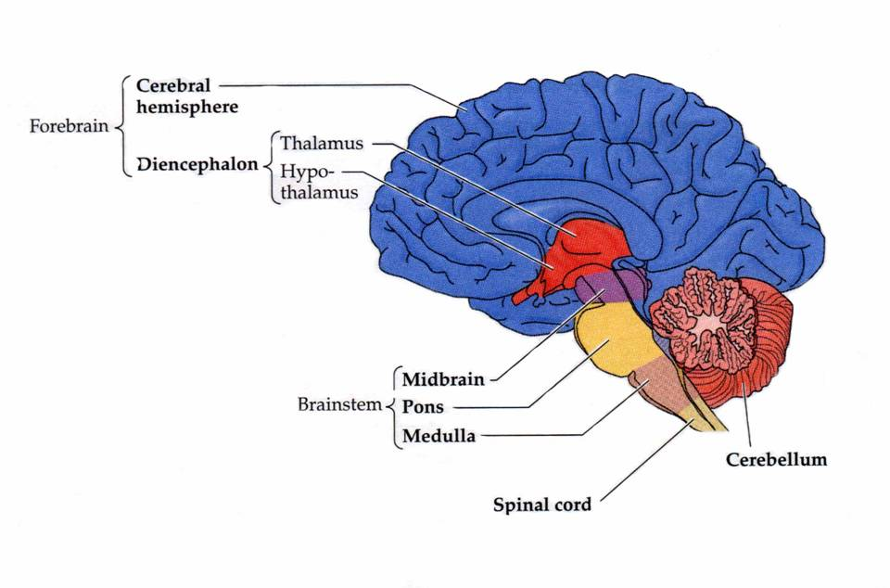
- Central (most neuronal somata, all interneurons, most innervating neurons) vs peripheral (nerves: axons from sensory and motor neurons; autonomic neurons; ganglia with somata sensory neurons) NS. Nuclei (collections somata CNS similar function), tracts (axons from nuclei). CNS: somatic (voluntary), autonomic NS (though integration inbetween). Redundancy in vertebrate system (probably due evolutionary duplication).
- Spinal cord (vertebrate analogue nerve cord), also segmented. 4 regions: cervical, thoracic, lumbar, sacral.
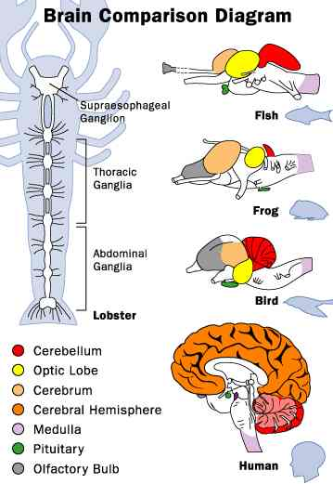
- Spinal cord: white matter (myelin; axons), grey matter (soma’s). Spinal canal continuous cerebral ventricles. Afferent axons dorsal roots (towards), efferent axons ventral root. Somata motor neurons ventral horn, interneurons receiving information dorsal horn.
- Medulla oblongata (respiration & autonomic function, relay information modalities and motor neurons), cerebellum (compares & integrates information muscle stretch & position joints [proprioreceptors] and visual and auditory systems; no direct connection spinal cord, via other brain regions),
- pons (fiber tracts that interconnect brain), tectum (/optic lobe; receives & integrates visual, tactile and auditory inputs; more important reptiles, birds), cerebral cortex (multilayered connection, taken over tasks tectum). Talamus (relay center sensory and motor signalling, and processing) → (mammals) cerebral cortex; → modify thalamus function.
- Amygdala (emotions) linked hypothalamus (functions survival: e.g. homeostasis, sexual appetite, also emotions). Anterior part: olfactory bulb (large primitive vertebrates, food odors, chemical communication, directly cerebrum), cerebral hemisphere (evolved cerebrum).
- Neural tube → expanded vesicles: forebrain, midbrain, hindbrain, center fluid filled cavity (→ cerebral ventricles & spinal canal); cell division along surface cavity: ventricular zone, then migrate → telencephalon (cerebrum), diencephalon (thalamus + hypothalamus), mesencephalon (tectum), metencephalon (pons, cerebellum), myencephalon (medulla oblongata), spinal cord. Some areas cerebral cortex purely sensory (primary projection visual, somatosensory & visual), purely motor; higher vertebrates also large regions association cortex (intersensory associations, memory, planning future, thought, communication).
- Space brain strict somatotopic map, allocated according relative importance.
- More neurons precise movements.
- (..) Visceral largely autonomic nervous system: sympathetic vs parasympathetic. Sympathetic: active/frightened (heartrate↑, skeletal muscles blood↑); Parasympathetic: relaxed (heart rate↓, housekeeping [digestion]).
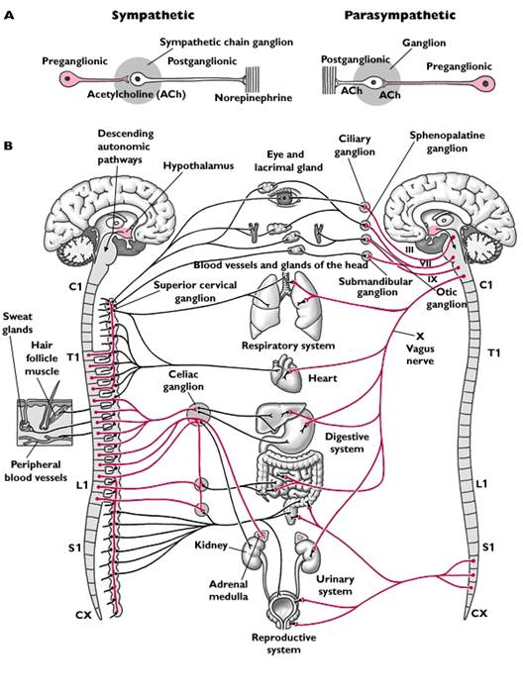
- Functional unit: reflex arc (“normal” afferent; efferent: motor output 2 neurons, sympatethic: preganglionic neuron and postganglionic neuron in sympathetic chain ganglion [outside CNS], parasympathetic: preganglionic synapse postganglionic neurons near/in walls target organs).
- Celiac ganglia contains somata sympathetic postganglionic neurons inervating stomach, liver, spleen, pancreas, kidney and adrenal gland). Sympatethic: thoracic and lumbar segments; Parasympatethic brain and sacral spinal cord.
- All preganglionic neurons cholinergenic (neurotransmitter ACh), postganglionic: parasymp.: ACh, symp.: norepinephrine. (..)

Organs in body cavity; Especially abdominal.

